TASK 2: AGILE PLANNING AND DEVOPS WORKFLOW

1. Task 2 Purpose
Task 2 converts the approved MVP scope from Task 1 into an Agile development plan. The project work is divided into user stories, acceptance criteria, backlog items, sprint activities and a Kanban flow. A Definition of Done is established so that each task has a clear completion standard. The DevOps lifecycle shows how development progresses from planning and coding through build, testing, containerization, deployment and operations.

2. User Stories and Acceptance Criteria
ID | Feature | User Story | Acceptance Criteria
US01 | Create Event | As an event organizer, I want to add event details so that events can be tracked for sponsorship activities. | Event name and date are mandatory; valid event details are stored.
US02 | Create Sponsor | As a sponsorship coordinator, I want to add sponsor details so that sponsor information is maintained centrally. | Sponsor name is mandatory; valid sponsor details are stored.
US03 | Create Sponsorship Record | As a sponsorship coordinator, I want to associate a sponsor with an event so that the sponsorship can be tracked. | An existing event and sponsor can be selected and the record is created.
US04 | Record Sponsorship Amount | As a sponsorship coordinator, I want to record the sponsorship amount so that the financial value is available. | A valid numeric amount is stored against the sponsorship.
US05 | Track Sponsorship Status | As an event manager, I want to track sponsorship status so that I know its current progress. | Status can be selected, updated and displayed.
US06 | Track Payment Status | As an event manager, I want to track payment status so that pending or completed payments can be identified. | Payment status can be stored, updated and displayed.
US07 | Update Sponsorship | As a sponsorship coordinator, I want to update sponsorship information so that changes are reflected. | An existing sponsorship can be edited and saved.
US08 | Search Events | As an event manager, I want to search events so that I can quickly locate an event. | Matching event records are returned; no-result searches are handled.
US09 | Search Sponsors | As an event manager, I want to search sponsors so that I can quickly locate sponsor records. | Matching sponsor records are returned; no-result searches are handled.
US10 | Dashboard Summary | As an event manager, I want summary indicators so that I can understand the sponsorship situation quickly. | Total events, sponsors, sponsorship amount and pending/exception count are shown.
US11 | Sponsorship List | As a user, I want to view sponsorship records in a structured list so that I can review them efficiently. | Records show key event, sponsor, amount and status information.
US12 | Status Drill-down | As an event manager, I want to open a sponsorship record so that I can view detailed status. | Event, sponsor, amount, sponsorship status and payment status are displayed.
US13 | Exception View | As an event manager, I want to see pending or overdue sponsorships so that records requiring attention are easy to identify. | Pending/overdue records are clearly listed or highlighted.
US14 | Input Validation | As a user, I want invalid or incomplete input rejected so that incorrect records are not stored. | Mandatory fields and invalid input are validated with feedback.
US15 | Application Health Check | As an administrator, I want to check application health so that I can verify availability. | A health/status check returns a successful response when operational.

3. Product Backlog
ID | Backlog Item | Priority | Story | Sprint | Status
PB01 | Create Event | High | US01 | Sprint 1 | To Do
PB02 | Create Sponsor | High | US02 | Sprint 1 | To Do
PB03 | Create Sponsorship Record | High | US03 | Sprint 1 | To Do
PB04 | Record Sponsorship Amount | High | US04 | Sprint 1 | To Do
PB05 | Track Sponsorship Status | High | US05 | Sprint 1 | To Do
PB06 | Track Payment Status | High | US06 | Sprint 1 | To Do
PB07 | Update Sponsorship | High | US07 | Sprint 1 | To Do
PB08 | Search Events | Medium | US08 | Sprint 2 | To Do
PB09 | Search Sponsors | Medium | US09 | Sprint 2 | To Do
PB10 | Dashboard Summary | High | US10 | Sprint 2 | To Do
PB11 | Sponsorship List | High | US11 | Sprint 2 | To Do
PB12 | Status Drill-down | High | US12 | Sprint 2 | To Do
PB13 | Exception View | High | US13 | Sprint 2 | To Do
PB14 | Input Validation | High | US14 | Sprint 2 | To Do
PB15 | Application Health Check | Medium | US15 | Sprint 2 | To Do

4. 15-Task Sprint Plan
Task | Work Item | Sprint | Planned Activity
1 | Create Event | Sprint 1 | Set up event entry and persistence
2 | Create Sponsor | Sprint 1 | Set up sponsor entry and persistence
3 | Create Sponsorship Record | Sprint 1 | Connect event and sponsor
4 | Record Sponsorship Amount | Sprint 1 | Store sponsorship amount
5 | Track Sponsorship Status | Sprint 1 | Implement status management
6 | Track Payment Status | Sprint 1 | Implement payment status
7 | Update Sponsorship | Sprint 1 | Allow existing records to be updated
8 | Search Events | Sprint 2 | Implement event search
9 | Search Sponsors | Sprint 2 | Implement sponsor search
10 | Dashboard Summary | Sprint 2 | Implement summary indicators
11 | Sponsorship List | Sprint 2 | Display sponsorship records
12 | Status Drill-down | Sprint 2 | Display detailed sponsorship status
13 | Exception View | Sprint 2 | Display pending/overdue records
14 | Input Validation | Sprint 2 | Validate required and invalid input
15 | Application Health Check | Sprint 2 | Verify application availability

5. Kanban / Task Board
Work items move through the following board as development progresses.
Board Column | Meaning | Example
BACKLOG | Approved but not started | All unstarted MVP tasks
TO DO | Selected for current work | Tasks ready for implementation
IN PROGRESS | Currently being implemented | Active development tasks
CODE REVIEW | Implementation completed | Changes awaiting review
TESTING | Feature under verification | Functional and automated tests
DONE | Meets Definition of Done | Accepted and completed work

6. Definition of Done
- The required functionality is implemented according to its acceptance criteria.
- The code follows the agreed project structure and naming conventions.
- Required input validation is implemented.
- The application compiles and builds successfully using Maven.
- The implemented feature is functionally tested.
- No known critical defect remains for the completed task.
- Changes are committed to Git using a meaningful commit message.
- Relevant documentation is updated where required.
- The feature works with the current MVP without breaking existing functionality.
- For CI/CD stages, the change passes applicable automated build and test checks.

7. DevOps Lifecycle

7.1 DevOps Workflow and Tools

Stage | Activity | Tool / Technology
Plan | Define user stories, backlog and sprint work | GitHub Issues / Kanban
Code | Develop application features | Java / Spring Boot / Git
Build | Compile and package the application | Maven
Test | Run automated user-journey tests | Selenium
Continuous Integration | Automatically build and test changes | Jenkins
Containerize | Build a deployable application image | Docker
Release | Version and publish the image | Docker Registry
Deploy | Run the application in the target environment | Docker / Nginx
Configure | Prepare and maintain the target environment | Ansible
Operate / Monitor | Check availability and recover when needed | Health Check / Rollback

7.2 DevOps Lifecycle Diagram

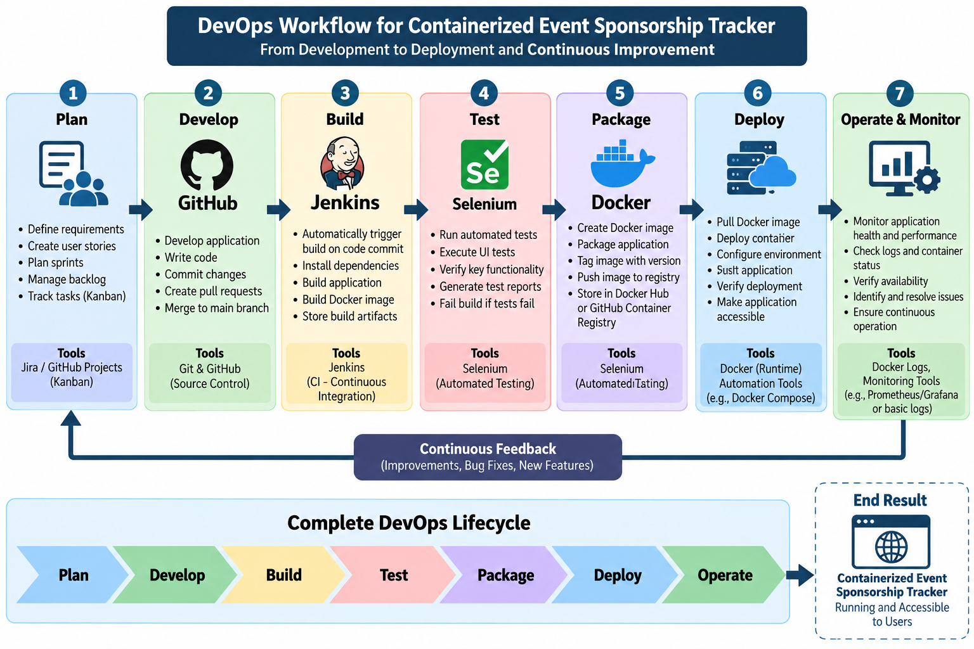

8. Task 2 Conclusion
Task 2 converts the approved MVP scope into an actionable Agile and DevOps plan. Each MVP function has been represented as a user story with acceptance criteria, organized into a product backlog and two implementation sprints. The Kanban flow and Definition of Done provide a consistent method for tracking and completing work, while the DevOps lifecycle defines the progression from development through automated testing, containerization, deployment and operations.

